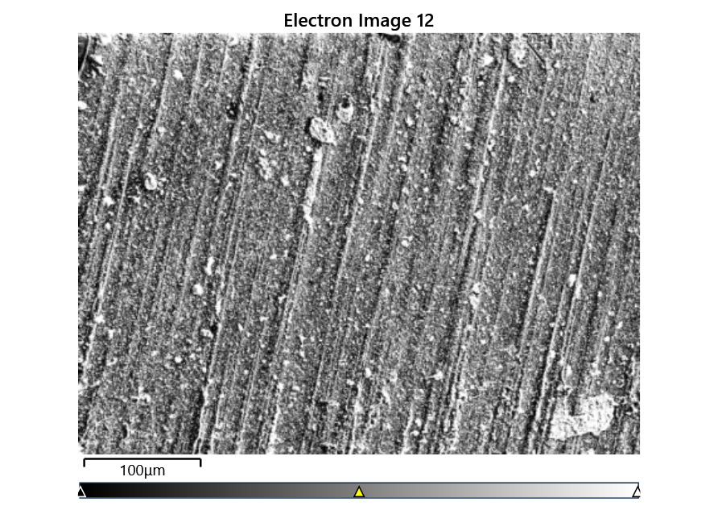



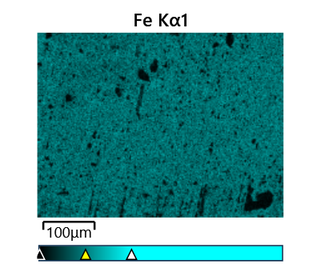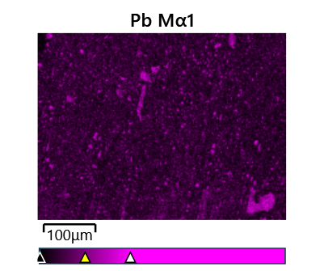

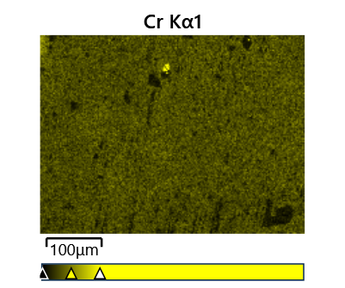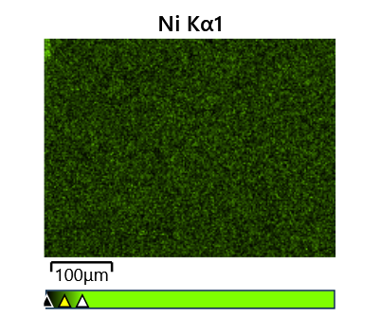

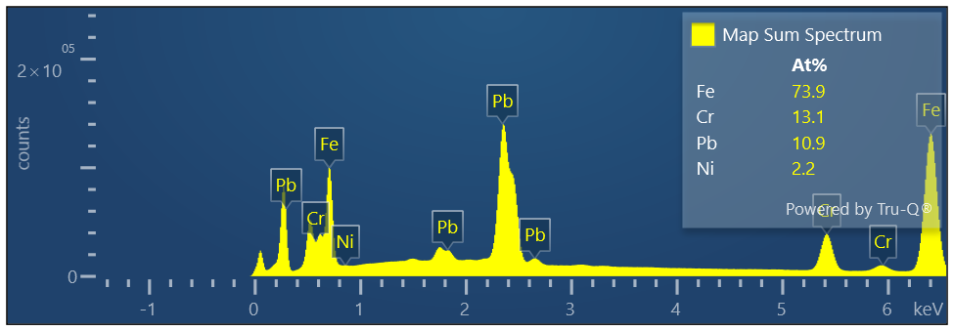

Map Sum Spectrum

Element Signal Weight % σ

Fe 57.43 0.06

Pb 31.31 0.06

Cr 9.45 0.03

Ni 1.81 0.03

Map Sum Spectrum

Element Signal Atomic % σ

Fe 73.87

Cr 13.06

Pb 10.86

Ni 2.21